

Practices for Secure Software Report

Table of Contents
Practices for Secure Software Report 1
Document Revision History 3
Client 3
Developer 3
1. Algorithm Cipher 4
2. Certificate Generation 4
3. Deploy Cipher 6
4. Secure Communications 6
5. Secondary Testing 7
6. Functional Testing 9
7. Summary 10
8. Industry Standard Best Practices 10

Document Revision History

Version | Date | Author | Comments
1.0 | 06/14/2026 | Alyana Garcia

Client



Developer
Alyana Garcia

Algorithm Cipher

AES (Advanced Encryption Standard) with a 256-bit key is recommended for this application because it provides strong protection for sensitive data and is widely used in modern systems. AES is a symmetric encryption algorithm, which means the same key is used to encrypt and decrypt information. AES-256 is considered highly secure because its large key size makes it extremely difficult for attackers to break through brute-force methods.

Although AES is used for encryption, it is often paired with hash functions such as SHA-256 to help protect data integrity. SHA-256 creates a unique 256-bit hash value that can be used to verify whether data has been changed. Using AES for confidentiality and SHA-256 for integrity helps create a stronger overall security solution.

AES relies on a shared secret key between the sender and receiver. It also uses random values called initialization vectors (IVs) to help ensure that the same data does not always produce the same encrypted result. This makes encrypted information more difficult to predict. Unlike symmetric encryption, asymmetric encryption uses separate public and private keys and is commonly used for secure key exchange rather than encrypting large amounts of data.

Encryption methods have continued to improve over time. Older standards such as DES were once widely used but are no longer considered secure because of their smaller key sizes and vulnerability to modern attacks. Today, AES is the industry standard for data encryption and is used by businesses, financial institutions, and government organizations. Its combination of security, efficiency, and reliability makes it an excellent choice for protecting application data (National Institute of Standards and Technology [NIST], 2001).

Certificate Generation

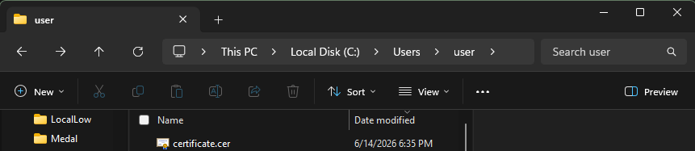
Figure 1.1. Exported Self-Signed Certificate (.CER) File
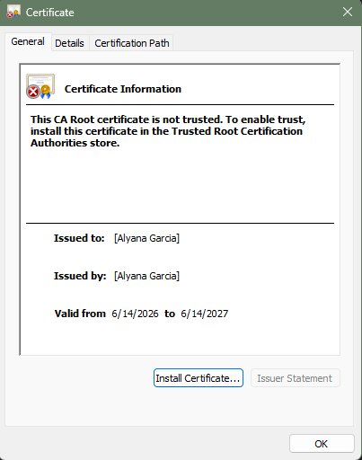
Figure 1.2. Self-Signed Certificate Details

Deploy Cipher

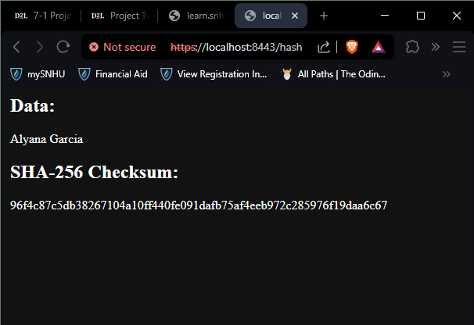
Figure 3.1. SHA-256 Checksum Verification Output

Secure Communications


Figure 4.1. HTTPS Connection to Local Server Using SSL Configuration

Secondary Testing

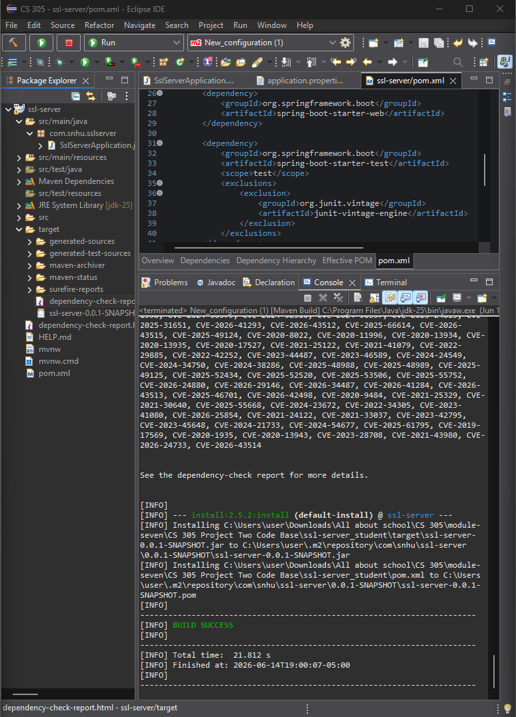
Figure 5.1. Refactored SSL Server Application Executed Successfully
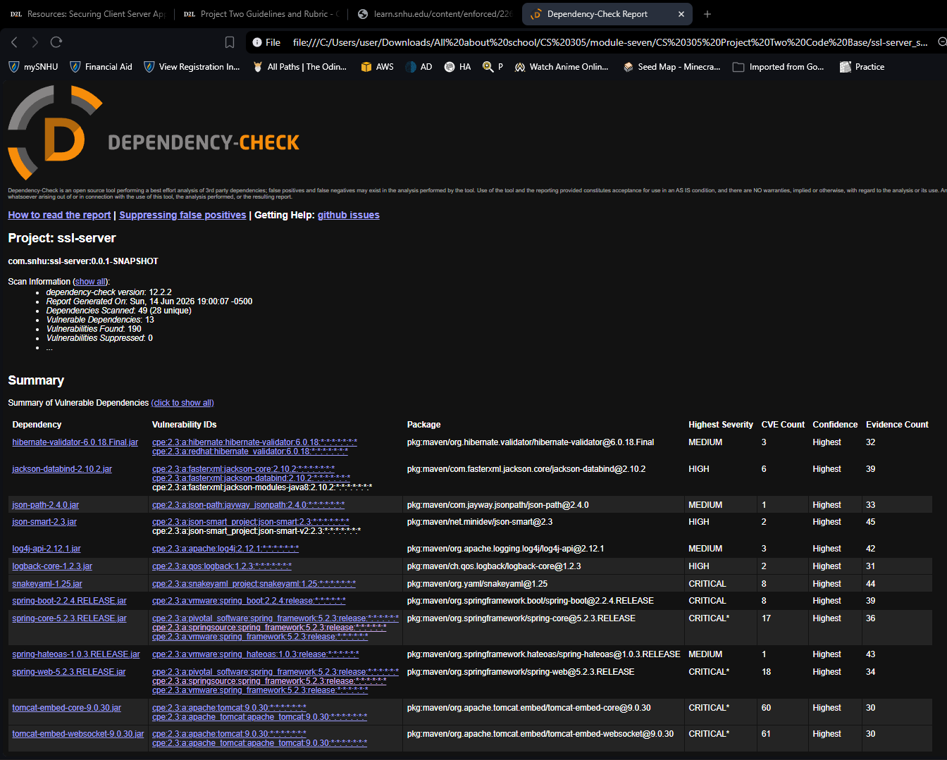
Figure 5.2. OWASP Dependency-Check Static Analysis Report

Functional Testing

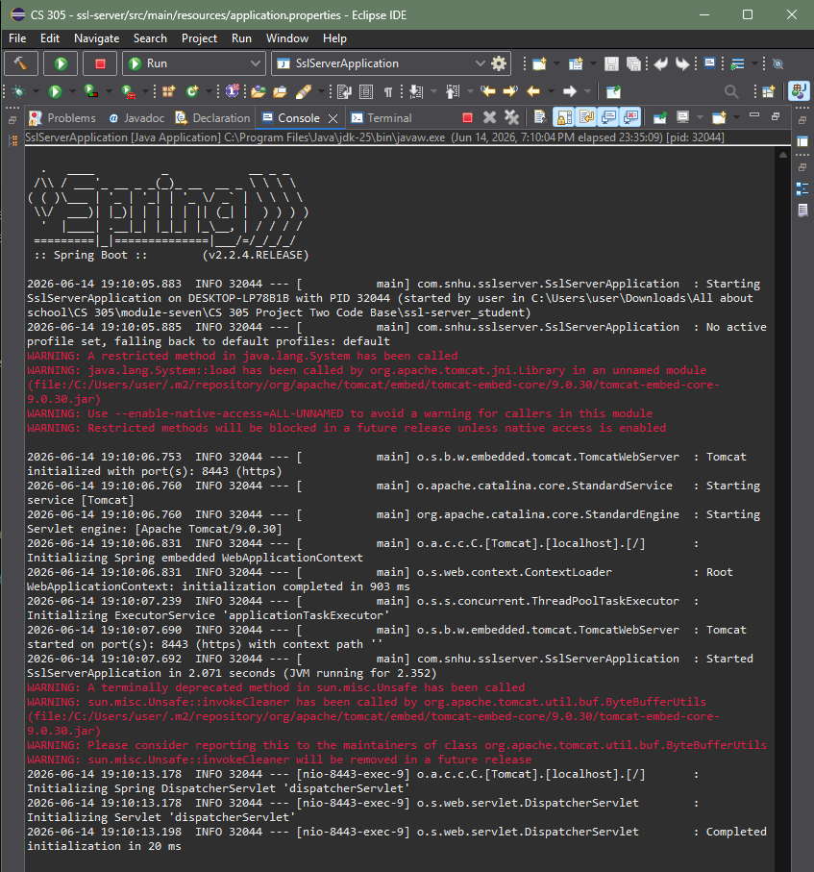
Figure 6.1. Successful Execution of the Refactored SSL Server Application

Summary

The code was refactored to improve the security of Artemis Financial’s application by adding a SHA-256 checksum feature and enabling HTTPS communication. This supports the vulnerability assessment process flow by addressing key areas such as Cryptography, where encryption and hashing are used to protect data integrity, and Client/Server security, where HTTPS is used to secure communication between systems. These changes help ensure that data is protected while being transmitted and stored.

Following the vulnerability assessment process flow, additional focus was placed on secure coding practices and identifying risks during development. The application was tested through Spring Boot execution, checksum verification, secure HTTPS access, and dependency-check scanning. These steps align with the flow from Architecture Review through Code Quality and Code Review, ensuring that both the application structure and third-party dependencies were evaluated for security risks before finalizing the mitigation approach.

Industry Standard Best Practices

Industry standard secure coding practices were applied throughout the development process to maintain the application’s security. This includes using SHA-256 hashing under Cryptography to ensure data integrity, and HTTPS under Client/Server security to protect data during transmission. Input handling and secure coding practices were also considered to reduce the risk of vulnerabilities introduced through application logic or external libraries.

These best practices are important for maintaining the overall security and reliability of the system. By following secure development standards and using dependency-check tools during Code Quality and Code Review stages of the vulnerability assessment process, the application reduces exposure to known vulnerabilities. This helps protect sensitive financial data and supports the company’s goal of providing secure and trustworthy software for clients.

References

National Institute of Standards and Technology. (2001). Announcing the Advanced Encryption Standard (AES) (FIPS PUB 197). https://csrc.nist.gov/publications/detail/fips/197/final

